Initial Application Concept

For team HistoryDevs as part of the module 6CS001

By Elliott Rees (1112028), Minesh Mitha (1128007) & Richard Crees (1124523)

We have decided to develop an interactive educational application. It is common for school level children to study the Second World War in detail. The purpose of this is application is therefore to outline the territorial occupation and movement of troops throughout Europe during the Second World War.

The proposed application will feature a 3 dimensional map of Europe. This map will be colour coded to show which powers occupied which land. A timeline shall also be present at the bottom of the application. The user will be able to drag this timeline and as the time changes, the colours outlining who occupies what territory will change accordingly. The territories controlled by the axis powers shall be displayed in red, and the territories owned by the Allies shall be displayed in blue.

Users shall also be able to click on object of interest upon the map. These objects include countries or cities. When an object of interest is clicked, further relevant information will be displayed. This relevant information will include but is not limited to troop numbers within the area and links to further information.

As initial research, we evaluated some of the static options available to teach this information. The application we have in mind will be similar to the image shown within Figure 1 (Worldology LLC, 2009). Figure one however has many colours to show territory controlled by individual countries. Ours will however feature only 2 colours, one of the axis controlled territory (red) and one for allied controlled territory (blue). Ours will also be 3 dimensional and change as the user changes the current time the map is representing.

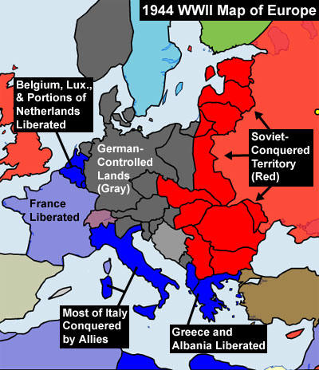

Figure : Map of Europe outlining owned territories- Source: (Worldology LLC, 2009)

This information is already available throughout books and websites. The interactive aspect of our proposed project however will make the learning experience of this information enjoyable and engaging. It will also be easier to visualise the changes in territorial occupation over time compared to analysing multiple static images.

# References

Worldology LLC, 2009. *World War II (1939 - 1945).* [Online]   
Available at: http://www.worldology.com/Europe/world_war_2_1944.htm  
[Accessed 05 02 2015].